**Trellix Sandboxing:**

**Sample Complete PB Steps:**

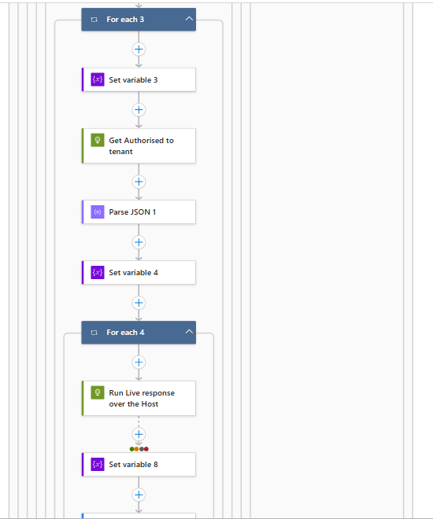

**PB Steps In depth:**

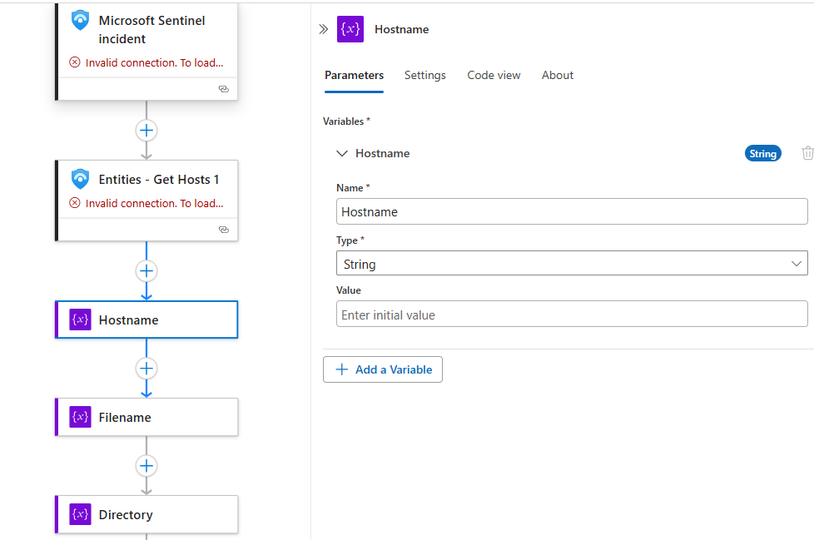

Like the above similar way call the below set of Variables:

Hostname -String

Filename – Array

Directory – Array

ProductName – String

DeviceID – String

AccountName – String

DeviceType – String

Manager UPN – String

Array DeviceID – String

Access token – string

Commanded – String

is_malicious – String

machine_action_id – String

machine_action_id_1 – string

http_status – String

http_status_1 - String

logic_app_action-id – String

password – string

Now here, start For each loop for Alerts.,, then set a variable like below.,

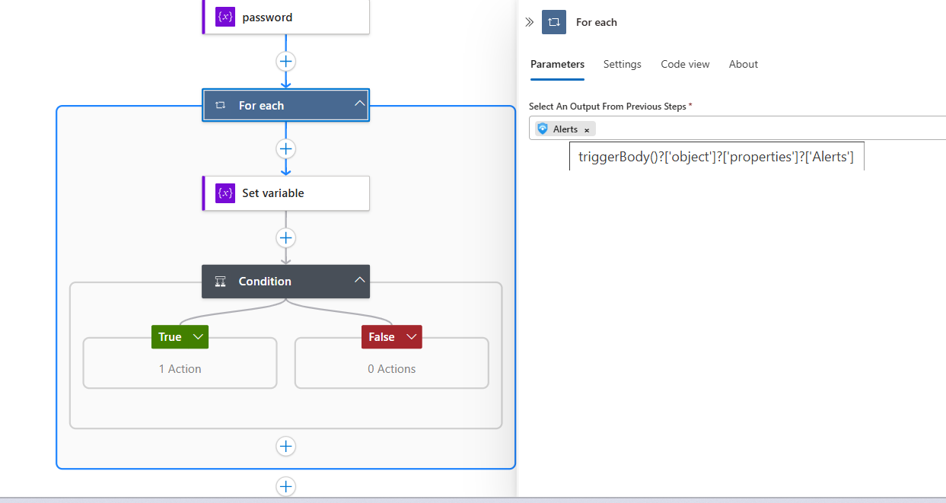

Now Start a conditional Loop and go with True Conditions.

**Here loop to fetch entities from alert --- this loop is normal For each and rename it.**

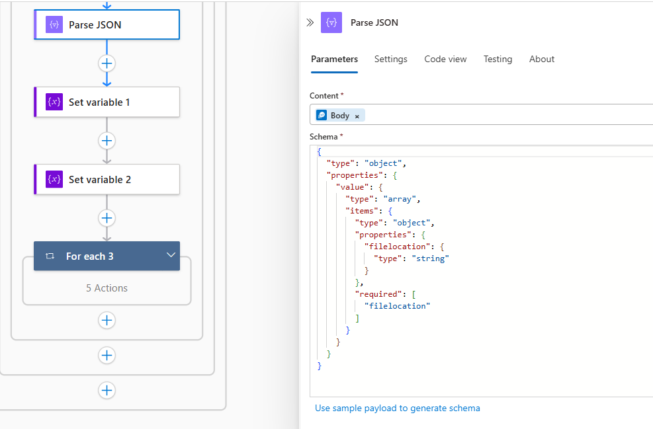

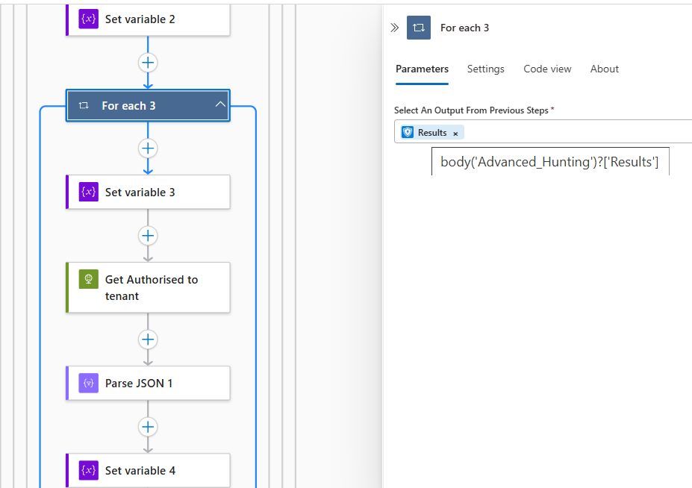

Here **Get Authorized to tenant** Is **HTTP API** call and rename it.

**Now here apply condition loop and go with true condition. Below Everything will be under condition4**

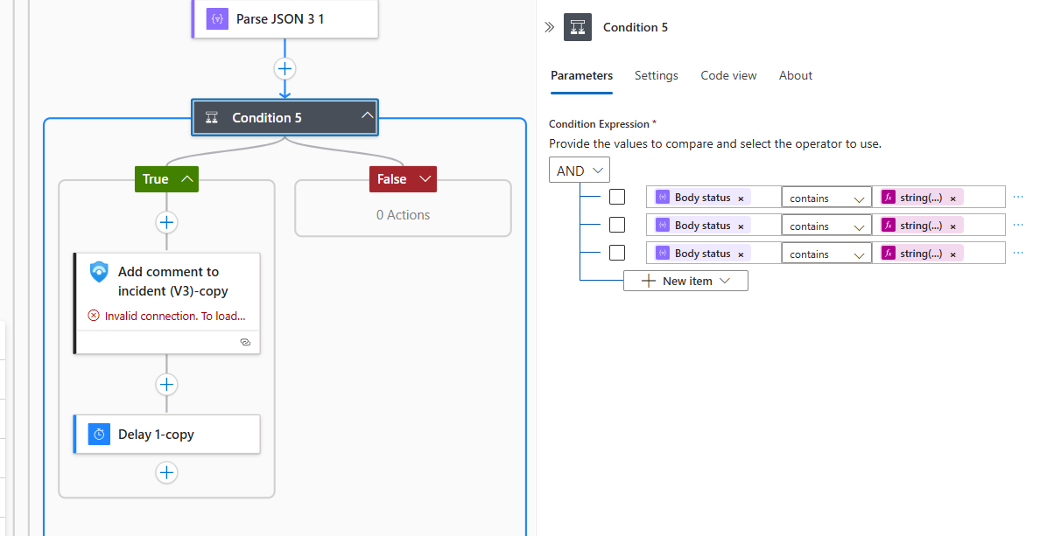

**Now here go with condition 1 with true condition.**

**Now go with False condition for condition1:**

======================================================================**End of Condition4 here for True condition**

Now let’s proceed with **False** step for **Conditional loop4:**

**Now here start conditional loop 6.,**

**Here comes the end of Conditional loop 6, now minimize this loop and go with next steps.,**

Now let’s go ahead with **the Conditional 1-copy** loop **true** condition:

**===========================================================================here comes end of True condition.**

Now let’s go ahead with **the Conditional 1-copy** loop **False** condition:

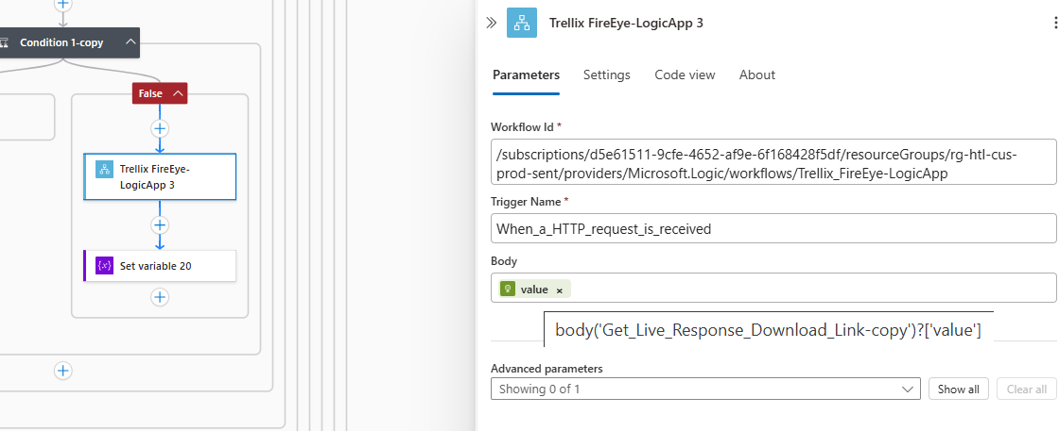**

==========================================================**End of False Condition**

**=======================================================================End of False condition of Condition4.**

Now proceed with the next steps:

Here to start with **add comment** section, minimize the condition4 loop and then add this add comment section tab after condition4 loop, below is sample screenshot.,

This Image is just for reference just to get understanding how to start with next loop,

Now apply one more conditional loop and proceed with true condition:

**Note: Whatever steps are their everything will continue under this conditional loop only.**

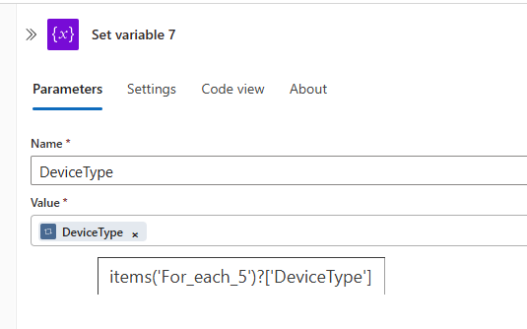

Now here go with conditional loop 3 true condition:

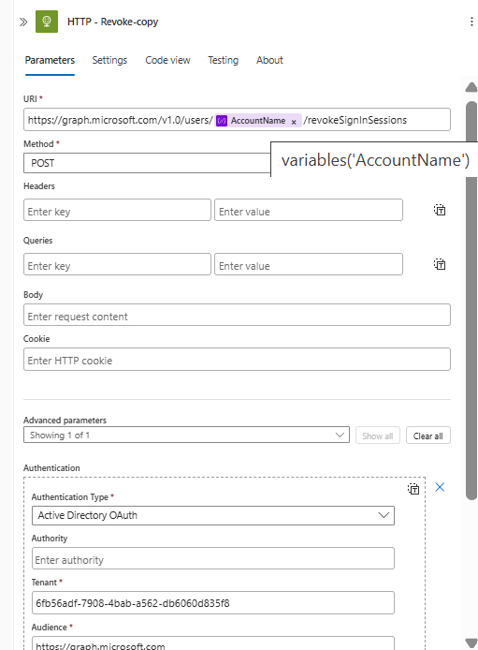

**Here let’s proceed with conditional loop 3 False condition:**

**Here let’s proceed with conditional loop 2 False condition:**

**=========================================================================================================**